Predicting Flood-Prone Areas of Pakistan
Tehsil-Level Monsoon Flood Extent, 2022–2025
Dataset 3 (Zenodo, uploaded to Kaggle) · Shahan Anwar, MS Artificial Intelligence

1. Dataset Description
Item | Details
Source | Zenodo: “A Multi-Resolution Geospatial Dataset of Monsoon Flood Extent and Spatial Clustering for Pakistan (2022–2025)” (CC BY 4.0)
How it was made | Flooded area was detected by the VIIRS satellite and combined with UNOSAT flood maps
Size | 577 tehsils × 4 years = 2,308 rows (also 160 districts = 640 rows)
Main columns | flooded area (km² and %), tehsil area, province, hot-spot scores (gi_z, hotspot, lisa_quad)
Note | It has no rain, height or slope columns. Flood area is a lower estimate because satellites cannot see through clouds.

Simple words: Each row is one tehsil in one year and says how much of its area went under water in that monsoon. A “hot spot” is a heavily flooded tehsil surrounded by other heavily flooded tehsils.
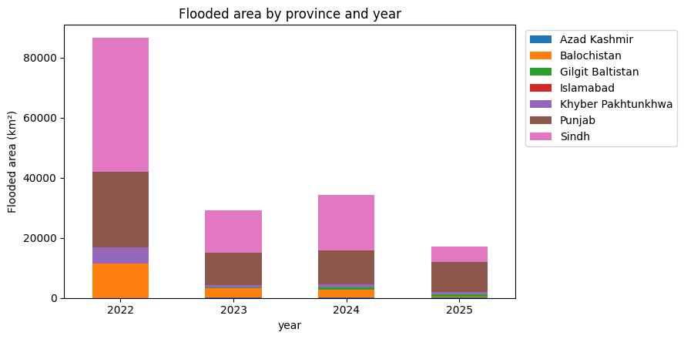
Figure 1: Flooded area by province and year
Year | Total flooded area (km²) | Tehsils over 10% flooded | Hot-spot tehsils
2022 | 86,524 | 31.5% | 94
2023 | 29,117 | 15.4% | 62
2024 | 34,228 | 17.2% | 58
2025 | 17,040 | 9.0% | 88

Observation: The 2022 flood was by far the biggest. Sindh and Punjab are hit the most every year. In 2025 the flooding moved to Punjab (60% of all flooded area, against 33% in 2024), while Sindh dropped from 54% to 29%. Balochistan fell from 11,529 km² (2022) to 379 km² (2025) and Khyber Pakhtunkhwa from 5,211 to 641. Floods of 2022, 2023 and 2024 are very similar to each other (similarity 0.83 to 0.85), but 2025 is different (only 0.38 to 0.44).

2. Problem Definition
Question: “Using this year’s flood, which tehsils will be seriously flooded (more than 10% of their area) next year?”
- This is like the flood-susceptibility maps of Papers 2 to 5 (which places are flood-prone), but here we only know past flood extent.
No leakage: The inputs always come from the earlier year and the answer from the next year.

3. Experimental Setup and Models
- Study (training): 2022→2023 and 2023→2024 (1,154 rows, 16% seriously flooded). Exam (testing): 2024→2025 (577 tehsils, 52 seriously flooded = 9%). The models never saw 2025.
- Inputs (14): % flooded, km² flooded, tehsil area, hot-spot scores, the average flooding of the district, and the province.

Model | Simple explanation
Baseline | “A tehsil that was seriously flooded this year will be flooded again next year.” Every model must beat this.
Logistic Regression | Draws one straight line between “flooded again” and “not flooded again”.
Random Forest | 300 decision trees vote; the majority wins.
XGBoost | Trees built one after another; each fixes the mistakes of the earlier ones.

4. Confusion Matrix and Evaluation Metrics
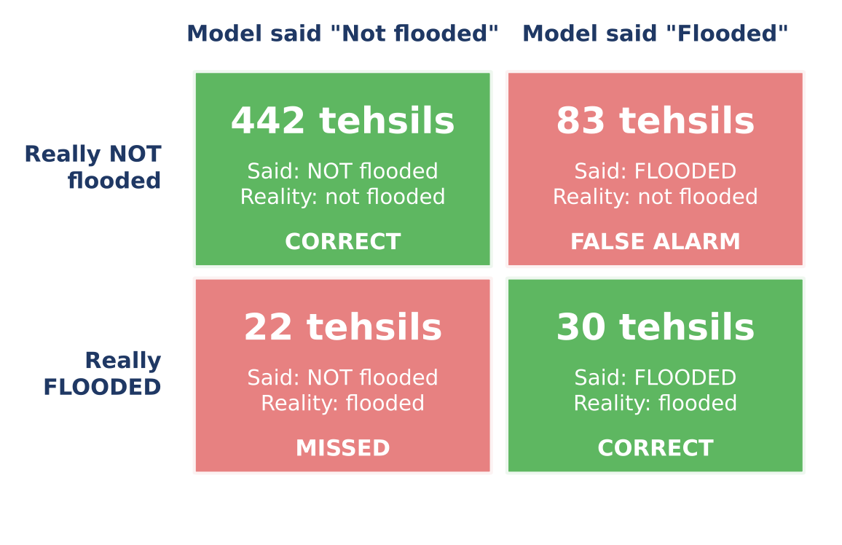
Figure 2: Confusion matrix of XGBoost on the 577 test tehsils
Observation: Rows show what really happened and columns show what the model said. Green boxes are correct (442 and 30). Red boxes are mistakes: 83 false alarms and 22 missed floods.

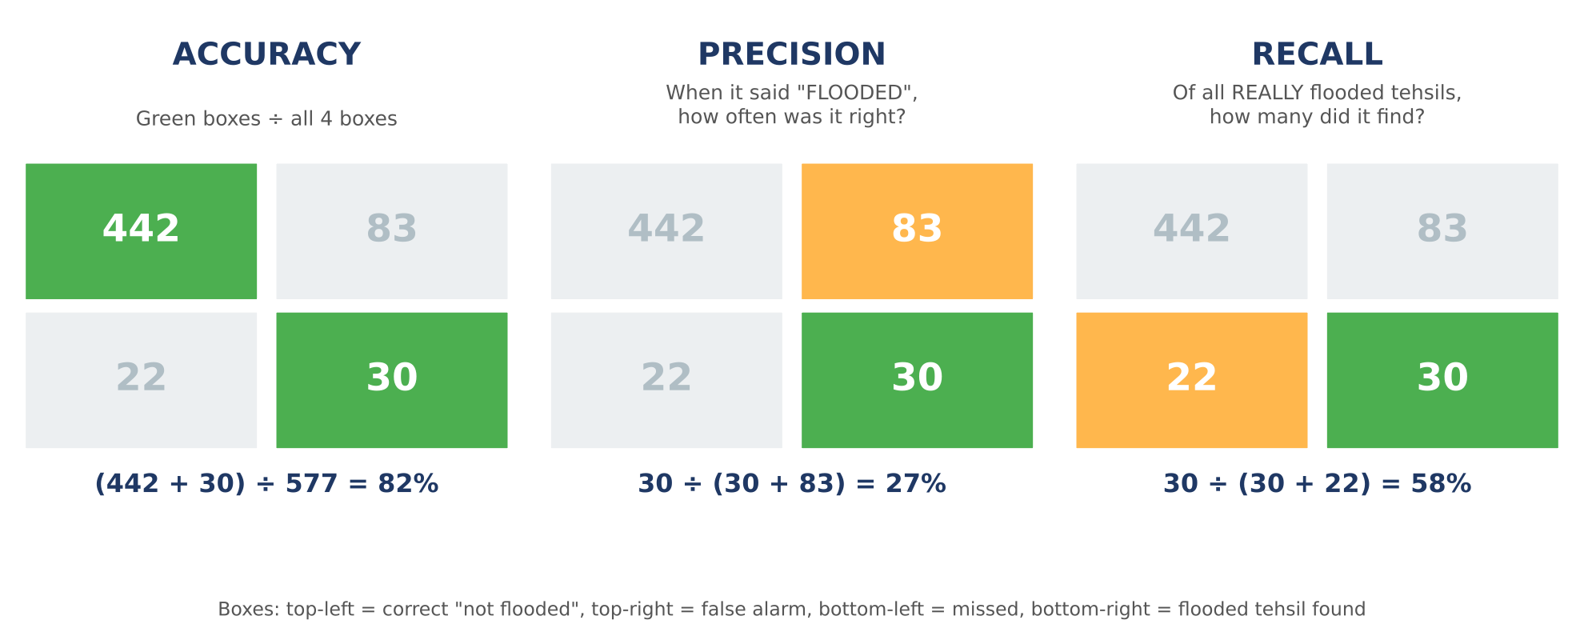
Figure 3: Where accuracy, precision and recall come from (XGBoost)
Metric | Meaning in simple words | XGBoost
Accuracy | Out of all tehsils, how many were predicted correctly. | 0.818
Precision | When the model says “flooded”, how often it is right. | 0.265
Recall | Of all really flooded tehsils, how many the model found. | 0.577
F1-score | One mixed score of precision and recall; high only when both are high. | 0.364
ROC-AUC | Overall skill at separating flooded from not-flooded tehsils. 1 = perfect, 0.5 = coin toss. | 0.805

Simple words: Only 9% of the test tehsils were seriously flooded. A lazy model that always says “not flooded” would get about 91% accuracy but find zero floods. So accuracy alone is not enough, and we look at precision, recall and F1.

5. Model Results
Model | Accuracy | Precision | Recall | F1-score | ROC-AUC
Baseline (same as last year) | 0.842 | 0.303 | 0.577 | 0.397 | 0.846
Logistic Regression | 0.806 | 0.254 | 0.596 | 0.356 | 0.852
Random Forest | 0.827 | 0.265 | 0.519 | 0.351 | 0.812
XGBoost | 0.818 | 0.265 | 0.577 | 0.364 | 0.805

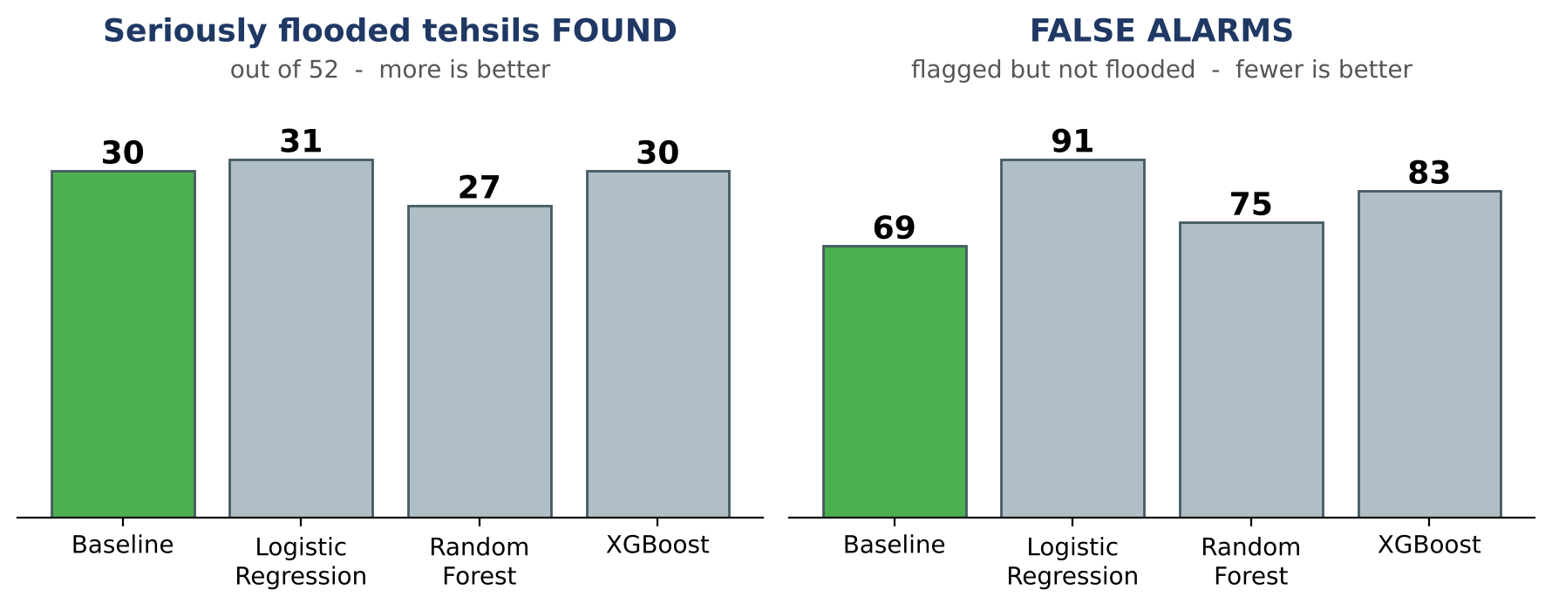
Figure 4: Flooded tehsils found and false alarms (green = best F1)
Observation: No model beats the simple baseline. The baseline has the best F1-score (0.397) and the fewest false alarms (69). Logistic Regression has the best ROC-AUC (0.852) but gives the most false alarms (91). All models find only about half of the seriously flooded tehsils (27 to 31 out of 52) and flag many tehsils that were not flooded.

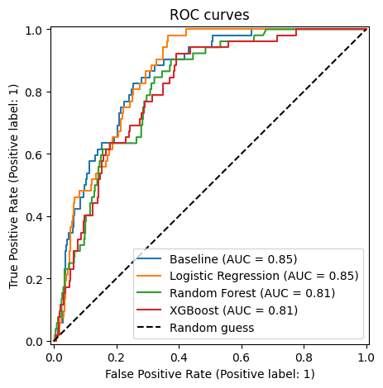  Figure 5: ROC curves | 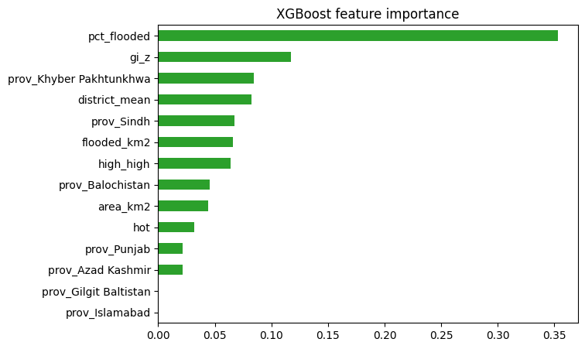  Figure 6: XGBoost input importance
Observation: Figure 5: the closer a line is to the top-left corner, the better. The baseline and Logistic Regression lines are slightly higher than Random Forest and XGBoost, and all are far above the dashed coin-toss line. Figure 6: a longer bar means the model used that input more. XGBoost mainly uses how much of the tehsil was flooded this year (pct_flooded), then the hot-spot score (gi_z).

6. Reality Check by Province (2025)
Province | Really flooded | Baseline flagged | XGBoost flagged | XGBoost correct
Punjab | 33 | 28 | 32 | 12
Sindh | 18 | 62 | 70 | 17
Balochistan | 0 | 6 | 9 | 0
Khyber Pakhtunkhwa | 0 | 2 | 1 | 0
Azad Kashmir | 1 | 1 | 1 | 1

Observation: Models learned from 2022–2024, when Sindh was hit hardest, so they flagged 70 Sindh tehsils but only 18 were really flooded. In 2025 the floods moved to Punjab, where 33 tehsils were seriously flooded, but XGBoost found only 12 of them.

7. Why We Split by Time
If we mix all years and split randomly, the same tehsil appears in both training and test (in different years), so the model can recognise it. This looks better but is not a real forecast:
XGBoost test | ROC-AUC | F1-score
Random split (unfair) | 0.934 | 0.663
Time split (honest, used here) | 0.805 | 0.364

8. Limitations
- Only 4 years of data, and the 2025 pattern is different from the earlier years.
- No rain, height, slope or river data, only past flood extent.
- Flood area is a lower estimate because satellites cannot see through clouds.

9. Conclusion and Link to My Thesis
- We used the flood extent of 577 tehsils (2022–2025) to predict which tehsils will be seriously flooded next year.
- No model beat “same as last year”: past floods alone give only a medium score (ROC-AUC 0.80 to 0.85, F1 below 0.40).
- The 2025 floods moved from Sindh to Punjab, so models trained on older years gave many false alarms in Sindh and missed most of Punjab.
- So past flood maps alone cannot show where the next flood will hit. My thesis adds satellite rainfall, weather and terrain data to predict flash floods hours ahead in KP and Balochistan.

